St. John’s Episcopal Church
A Return to Vibrancy

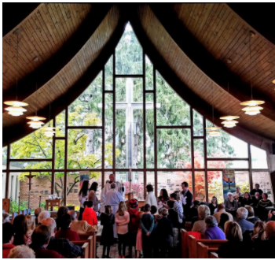
The people of St. John’s are pleased to present this update to our Parish Profile. The original Profile was published in August 2021; however, even prior to that time, positive energy and momentum were building in this congregation. People were coming back to the church—first for virtual services, then outdoor services, and finally, indoor worship. Special gifts began flowing in which have funded so many special projects. Not only are we healing, we are returning to vibrancy! This return to vibrancy reflects the love and energy the congregation has for our parish home, each other, and the community: all of which is an expression of our love for God.

St. John’s Episcopal Church
574 S. Sheldon Road
Plymouth, MI 48170

734-453-0190

www.stjohnsplymouth.org
https://www.facebook.com/StJohnsEpiscopalPlymouth
Rev. 12/22
Our mission is to share the joyful love of Christ.
Come walk with us.

Table of Contents
Our Values 3
What We Value in a Future Rector 3-4
St. John’s Parish Community 4-6
The Plymouth Community 6-7
Deep Roots 7
Our Values 7
Outreach and Community Partners 8
Challenges and Opportunities 8-9
Core Values 9
Financial Information 9
Membership Information 10
Diocese of Michigan Information and How to Apply 10

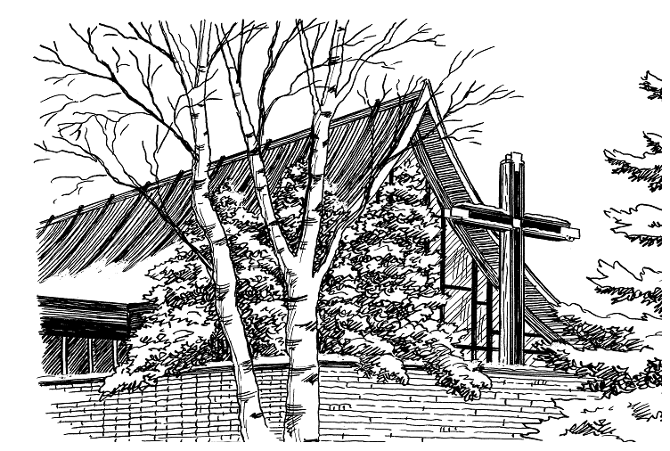

Our Values
Our highest values are centered around community and spirituality. Throughout our rich history—
St. John’s celebrated its 100th birthday in 2012—the congregation has consistently embraced three primary commitments: to God through lively worship & music; to each other in developing a rich social-spiritual life; and to service to the community. Few things connect us to each other and the community like music and service as an expression of our love for God.

What We Value in a Future Rector
St. John’s has a rich history of worship, community involvement, and service. Despite our challenges with many clergy changes in the last several years, we have continued to do the work that is important to us to keep our church and programs intact and successful. We seek a modern, energetic leader that can effectively listen and represent all generational groups within our Body of Christ. We need someone to inspire, organize, and encourage the talents and leaders in our church to create the next evolution of our faith and community.
We seek a modern, energetic leader that can effectively listen and represent all generational groups within our Body of Christ. We need someone to inspire, organize, and encourage the talents and leaders in our church to create the next evolution of our faith and community.

There is something incredibly special about St. John’s. Many people have expressed that they just feel different when they walk through our doors and sit in our sanctuary. Whether it is watching the birds sitting amongst the first spring blossoms in the memorial garden or watching the snow fall on the lit cross during Christmas Eve service, it is a place that effects change. It is a place where you can truly feel God’s presence when you take the time to listen. It is a calming balm to the soul and feels like “coming home and snuggling in God’s arms” and “rejuvenates (the) soul”. Our worship service is particularly important and is the foundation of our faith that reminds us of our humanity and Jesus’ teachings. This is what rejuvenates us through the next week to do God’s work in our daily lives. We have always been known for our wonderful music program and seek a rector that can orchestrate a beautiful melding of message and music on our Sundays to inspire, teach, and heal.

St. John’s is located in the thriving community of Plymouth, MI. We have a vibrant, young community with many families moving into the area. Unfortunately, few of those families and young adults participate in our church. Many churches across the country experience this. We seek a rector that can work with us to reach out to this community and meet them on their level. There is most definitely a need. Our community is considered an affluent community, but we also have issues with poverty, homelessness, hunger, crime, gangs, sex trafficking, and drug abuse. Our high schools have both a food bank and a clothing bank. Recent years have taught all of us that for some of our parishioners, physical and emotional needs are not being met. We want to learn to work together and seek help for basic needs as well as spiritual and emotional needs whether you are a religious person or a lost soul. We have facilities, resources, and knowledge that can reach out and complete God’s work in our community. We need new ideas and energy to help us make this work possible.

We desire a rector who listens and is willing to deal with all the difficult and messy emotions of life. Recent years have taught us that this is important. We also wish to cultivate an environment where people feel welcome to bring their messy life to God’s table and experience love, understanding, and hope. We are a progressive congregation that welcomes all God’s people. Our call is to follow Jesus’ commandments and genuinely love one another as He loved us. Please come and help us to work God’s message and to create God’s kingdom in our little corner of this big, beautiful world.
We need a Rector who listens and is willing to deal with all the difficult and messy emotions of life. Recent years have taught us that this is important. We need to cultivate an environment where people feel welcome to bring their messy life to God’s table and experience love, understanding, and hope.

St. John’s Parish Community
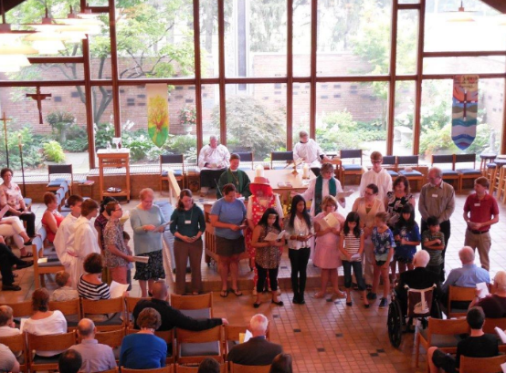
“St. John’s is a welcoming and enlightened community,” declared a Plymouth Township official when asked to describe “who we are.” He was not a member of our congregation but knew that we had made our church available for community groups when other churches and organizations in our area had turned them away. To us, it was the Christian thing to do. It is easier to entice our members to resupply our Food Bank, which is open to hungry families in and beyond our parish, than to support social gatherings. Several times during the year, our members reach out to prepare and serve meals to those who are hungry in Detroit. A group of our men raise enough money to provide more than 1,500 pairs of socks to help those in need every winter. These are just a few examples of what we do and what we value.

Our membership comes from many surrounding areas. St. John’s has many highly educated members in a variety of fields who step up and offer their expertise and time when it is needed. The pandemic crisis made this even more evident.

Worship & Services
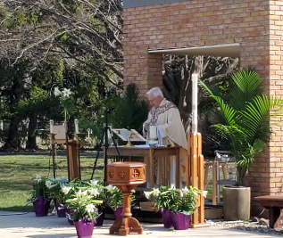
St. John’s continues to adjust to the ‘new world’ of in-person worship while simultaneously offering live-stream hybrid worship. Our House Band has re-formed; we have a new organist/pianist; our choir is slowly rebuilding; and our overall attendance is approaching our pre-pandemic numbers. We continue to welcome all and have some new members accepting our welcome and joining us. We continue to reinvent ourselves as the situation continues to change. We are pleased to have an 8:00 a.m. live Eucharist service, a 10:00 a.m. live and live-stream service, and a Sunday 8:00 p.m. Zoom Compline.

Additionally, we hosted a spectacularly successful parish dinner to celebrate our fellowship and return to vibrancy. It was attended by 100, and half the event was generously paid for with a special gift.

We are deeply grateful for the leadership of our interim rector who joined us just prior to the covid lockdown. Not only did he help us navigate a difficult, frightening and uncertain era, he did it with grace, hope and vision.

Fellowship
Bible study, prayer groups, book clubs and more are the staples of our congregation. Even during the early days of the covid lockdown, groups stayed connected virtually for prayer, Bible study and book club. In fact, some virtual groups actually expanded during this time!

Music Ministry
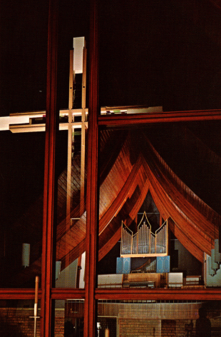
We love music and place a high premium on it to enhance our worship. Many parishioners are musicians and most look forward to having special live performances as a part of our services. Over the years, we’ve had amazing music directors leading a traditional choir, a contemporary band, a youth choir, and a handbell choir. In addition to our organ, a 1971 Gabriel Kney, 2-manual, encased, tracker action, 22 rank, 17 stop pipe organ (left), we are proud of our Kawai Baby Grand piano.

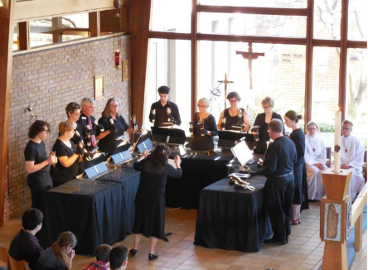
Most recently, we have been blessed to have a dedicated organist-pianist and a soloist as a regular part of our 10 a.m. Sunday service, joined by our modest and loyal choir. Our House Band has come together once again and adds to our possibilities each week. We have found a comfortable balance between our House Band and more traditional music.

Our Handbell Choir has found new life and plays monthly at our 10 a.m. service. We have installed a new electronic carillon which adds to the overall experience of worship and rings out to announce St. John’s is back and healthy. We’ve also hosted two special events at the church: an Organ & Piano Recital, and a Classical Bells concert.
Embracing Technology
During the covid lockdown Parishioners offered their time, talent and treasure to overcome the challenges of worship. Initially, we began worshipping outdoors under the shade of a magnificent Maple tree. As the weather chilled, we moved inside and developed our capabilities on Zoom, continually working to bring the congregation together for worship and Bible study and prayer groups. We added a soundbar and camera unit in our Gathering space that allows us to host hybrid meetings, as each of our groups has added members from outside the local area. As we returned to in-person worship in August of 2021, we invested in a YouTube channel and the equipment required to engage those at home with a sophisicated livestream. We are attempting to open a Zoom coffee hour so those on the livestream can connect to others as worhip concludes. This technology in our Gathering space is once again becoming a hub for community and Diocesan meetings with the possibility of their being hybrid. All through the pandemic, we gained new members, many of whom have been in the forefront of our venture into technology.

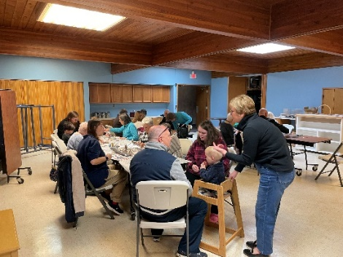
Inter-generational Fellowship
Our Sunday School has morphed into an inter-generational program. We recognize that families are changing the ways in which they work, play and pray together. When families choose to spend their time together in our church, we want to welcome them with spiritual enrichment as well as fellowship and a sense of community. The richness of this inter-generational fellowship feeds our souls!

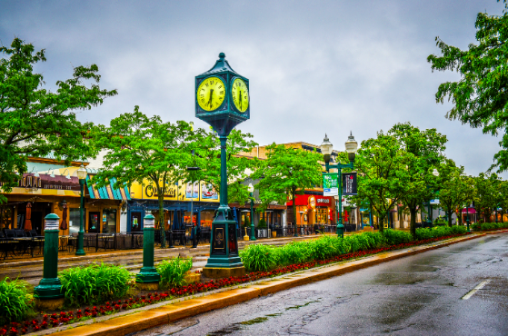
The Plymouth Community
The “Plymouth Community” includes the City of Plymouth, which has the main business district, and is surrounded by Plymouth Township. St. John’s Episcopal Church is located on the inner edge of the Township boundary facing the City and shares its northern boundary with West Middle School. The City and the Township share most amenities, but they maintain separate governments. There is a strong commitment currently to work together in many areas.
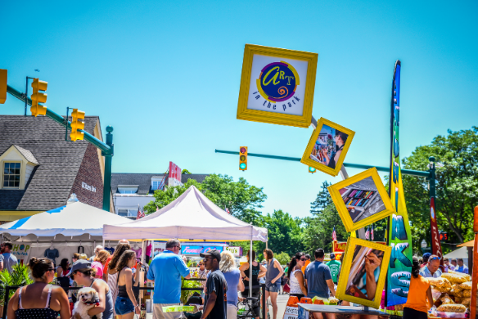
The City has a population of around 10,000 people living within its 2.2 square miles. Its business district surrounds popular historic Kellogg Park with its fountain. Many people are attracted to the numerous downtown shops, restaurants, festivals, concerts and other events. This is not a sleepy little village anymore. Known for its thriving business district, restored family movie theater, outstanding library, historical museum, large Community Band and professional Michigan Philharmonic, it is an exciting place. The Plymouth Arts and Recreation Center (PARC), a pottery center, the Cultural Center with its ice-skating rink and meeting rooms, the Community Arts Center and Gallery, and historic Old Village are all a short distance from the heart of the business district. The compact layout and central location of the downtown make Plymouth a walkable and bike-able town.
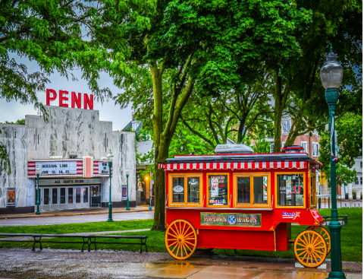
Covering 16 square miles, the Township has about 28,000 residents. It has a number of beautiful subdivisions and several parks. The largest park has 80 acres with water features, walking trails, several baseball fields, picnic area, etc. It is situated adjacent to the Township Golf Course. The Township has recently become famous for several large industrial research parks populated with nationally known company branches. There are engineers of many nationalities working in these centers creating upscale jobs, making the area and our schools more diverse than in previous decades.

The Plymouth area combined with Canton Township has an excellent school district, one of the largest in the state, as well as religious and private schools. The unique high school campus, called PCEP, has 3 high schools on one large college-style campus that educates approximately 7,000 students per year. Many colleges and universities are within easy driving distance, as are other institutions of interest. Some are: Schoolcraft College—one of the largest and most outstanding community colleges in the state—University of Michigan, Eastern Michigan University, Madonna College, University of Detroit, Wayne State University, and Lawrence Tech to name a few. The Henry Ford Museum in Dearborn, St. Paul’s Cathedral (and diocese offices), the Detroit Institute of Arts, the Detroit Symphony, Fisher Theater, Belle Isle, the Detroit Lions, Detroit Tigers, and Detroit Red Wings and much more are within 30 to 45 minutes of the Plymouth Community.

Plymouth residents and businesses have quick access to nearby major highways on the outskirts of the area which can quickly put them on their way to anywhere in the rest of the state they may wish to go. Detroit Metropolitan Airport (DTW) is about 20 minutes away.

Deep Roots
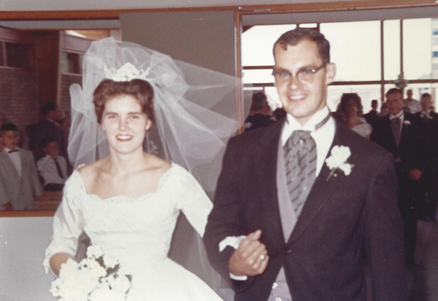
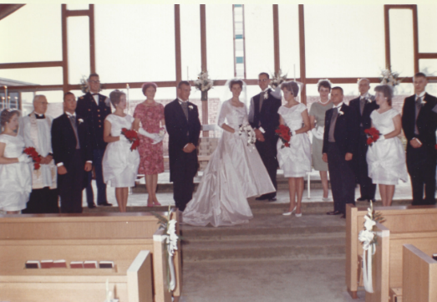
We are proud of our long history in the Plymouth community. Founded nearly 110 years ago, we are honored to have at least 2 parishioners who have been with us for about 70 years. The wedding photos below were taken in 1962 in our current facility when it was just 2 years old. The “bride” is still a vital part of the St. John’s family, just as St. John’s has been central to her family life. She met one of her dearest friends the first time she attended a service here when she was just eleven years old; 70 years later, that friendship is going strong. And, as you might imagine, she and her family have celebrated all of life’s most joyful, and sorrowful, moments at St. John’s.
We are humbled by and grateful for the many, many people who have called St. John’s “home” over the years. Each heart lifted in prayer and each voice lifted in song has left an indelible imprint of joy and hope that is palpable in our sanctuary.
Outreach and Community Partners
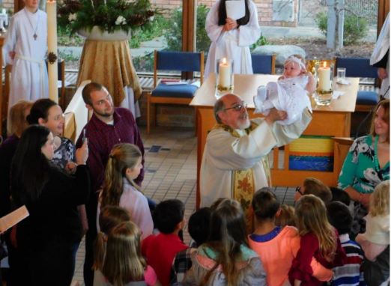
While we are passionate about current programs, there is still much to be done in our own backyard. Although Plymouth is an affluent community, there is a disparity of wealth in the area. Many families struggle with issues of poverty, addiction and even homelessness. This is the part of Plymouth we don’t like to see or talk about; in fact, many residents would be surprised to learn of this need. St. John’s is in a position to make a bigger impact right here in our community where the need is surprisingly great.
Community Partnerships
- Crossroads (social services agency in Downtown Detroit)
- Miss Millie’s Closet (durable medical equipment)
- St. John’s Food Pantry. During the covid lockdown, we’ve managed to keep all three of these important ministries active to some extent. Our pre-covid outreach was much broader and we look forward to extending outreach again soon.
- Refugee Ministry: St. John’s House for New Americans Together with the Episcopal Diocese of Southeastern Michigan and Samaritas, a Lutheran resettlement agency, St. John’s embarked on a mission to convert the vacant rectory to a temporary shelter for refugees.
- Refugees are people forced to leave home because of persecution, war, or violence and are fully vetted by the U.S. State Department for entry into the country.
  - Received grants totaling $40,000, including one in the unprecedented amount of $30,000 from the Trustees of the Episcopal Diocese of Michigan. Additional $5,000 from the Plymouth Rotary, plus another $10,000 gift.
  - Partnerships include the Episcopal Diocese, Plymouth Rotary, First Presbyterian Church- Plymouth, The Living Peace Church-Plymouth, Canton Community Foundation,
  - St. John’s House is an approved charity in the Kroger Community Rewards Program. Five percent of purchases will go toward our goal of $120,000.

Challenges and Opportunities
Leadership Prior to covid, we had been in a lengthy transition period with clergy turnover and dwindling membership; we have been without a settled Rector since 2017. With each turnover, we’ve lost more parishioners. We had been grieving the loss of our vibrancy and longing for the return of a more robust parish life. Ironically, as we began working through “covid issues”, we began to feel a sense of renewal.
Community Growth The recent growth in the Plymouth community includes many young families and young professionals. In this era when people feel they don’t have time for or are losing interest in church, St. John’s has an opportunity to connect with those seeking Christ and/or a church home simply by having more of a presence in the community.

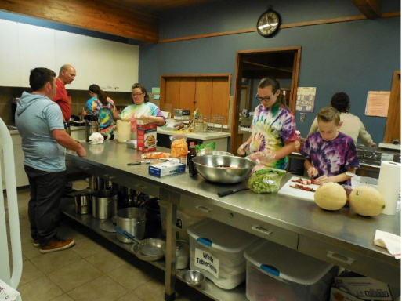
Where is St. John’s? One of our biggest challenges is that many of our neighbors don’t know we exist—even though we have been in our current building since June 1960! One community resident said he drives by almost daily, but has never been drawn to notice or read the sign in front. Our beautiful worship space, gathering hall and parish hall, combined with our fully-licensed kitchen and spacious parking lot, equip St. John’s to be hosts and partners to a wide variety of community events. A surprising lesson we learned during our Discovery Process that really resonates is “The longer a church has been in existence, the less connected it is to its community.” We are primed and ready to connect; and, in fact have been increasing that connection since covid.

Core Values
Inclusivity – We reach out to anyone who needs a safe and genuinely welcoming place to seek to know God.
Worship – We find God’s presence in the traditions of the Episcopal liturgy, in the scriptures, and in the music and are instructed, comforted, renewed, and challenged by them.
Discipleship – We are called to share our personal relationship with God, through Jesus Christ, and to share Christ’s love with all people through worship, education, and ministry.
Caring and Compassion – We are committed to serving and giving in the name of Jesus for spiritual, emotional, and physical needs in our parish, locally, and in the world.
Community – We come together as individuals to become the body of Christ. As such we use our spiritual gifts to rejoice together, mourn together, and to delight in each other, make others’ conditions our own.

Financial Information
 | 2005 | 2010 | 2015 | 2018 | 2020
Operating Revenues | $471,232 | $ 445,791 | $474,776 | $357,119 | $287,077
Operating Expenses | $442,040 | $425,751 | $467,377 | $326,126 | $257,295
Non-Operating Revenues | $ 31,543 | $ 17,786 | $ 88,653 | $ 12,213 | $ 28,847
Non-Operating Expenses | $ 43,268 | $ 43,573 | $ 32,340 | $ 6,591 | $ 27,984

Our income numbers skew a bit as large gifts of stock were received in 2020 and again in 2022. The trend is good thus far for 2023, showing an over 15% growth and 17 new pledges.

Membership Information
 | 2005 | 2010 | 2015 | 2018 | 2020
Baptized Members | 1,005 | 636 | 736 | 319 | 309
Baptisms | 15 | 11 | 9 | 2 | 0
Confirmations/receptions | 4 | 2 | 12 | 3 | 0
Average Sunday Attendance | 236 | 211 | 220 | 134 | 108

Just as we completely revamped our financial reporting system in 2020, we are now engaged in completely reworking our membership records so our numbers are accurate.

Come Walk With Us!
We are already praying for you and look forward to the day you become part of our parish family!

Diocese of Michigan Information and How to Apply
