A PUBLIC LITURGY FOR THE STRANGER

Leader:
We gather here in the sight of God
and in the sight of this city (village/town)
We gather for our neighbors.
We gather in support of immigrants and refugees.
We gather for the stranger.

Silence (30 seconds - let traffic noise be part of it)

Scripture Deuteronomy 10:18–19
“God executes justice for the orphan and the widow,
and loves the stranger, giving them food and clothing.
You shall also love the stranger,
for you were strangers in the land of Egypt.”

Pause.

Leader:
Standing here, in this place, in this moment,
we dare to believe that prayer matters.
And so we cry out:

Litany for the Stranger

Leader: For families separated
People: Holy One, make your presence known.
Holy One, show us your face.
Holy One, hear our prayers.

Leader: For people living in fear
People: Holy One, make your presence known.
Holy One, show us your face.
Holy One, hear our prayers.

Leader: For those detained
People: Holy One, make your presence known.
Holy One, show us your face.
Holy One, hear our prayers.

Leader: For officers and officials entrusted with power, grant them wisdom and compassion.
People: Holy One, make your presence known.
Holy One, show us your face.
Holy One, hear our prayers.

Leader: For laws that wound and systems that dehumanize, turn hearts toward justice.
People: Holy One, make your presence known.
Holy One, show us your face.
Holy One, hear our prayers.

Leader: For the Church when we grow timid, Make us brave in love.
People: Holy One, make your presence known.
Holy One, show us your face.
Holy One, hear our prayers.

Leader: For the stranger
People: Holy One, make your presence known.
Holy One, show us your face.
Holy One, hear our prayers.

The Lord’s Prayer

Sending
Leader: We leave here empowered.
People: We will speak.
We will advocate.
We will accompany.
We will vote.
We will remember.
We will pray.

Leader: May our faith be visible.
May our love be concrete.
May our courage be public.

In the name of the God who loves the stranger, the Christ who became a refugee, and the Spirit who blows where she wills. Amen.
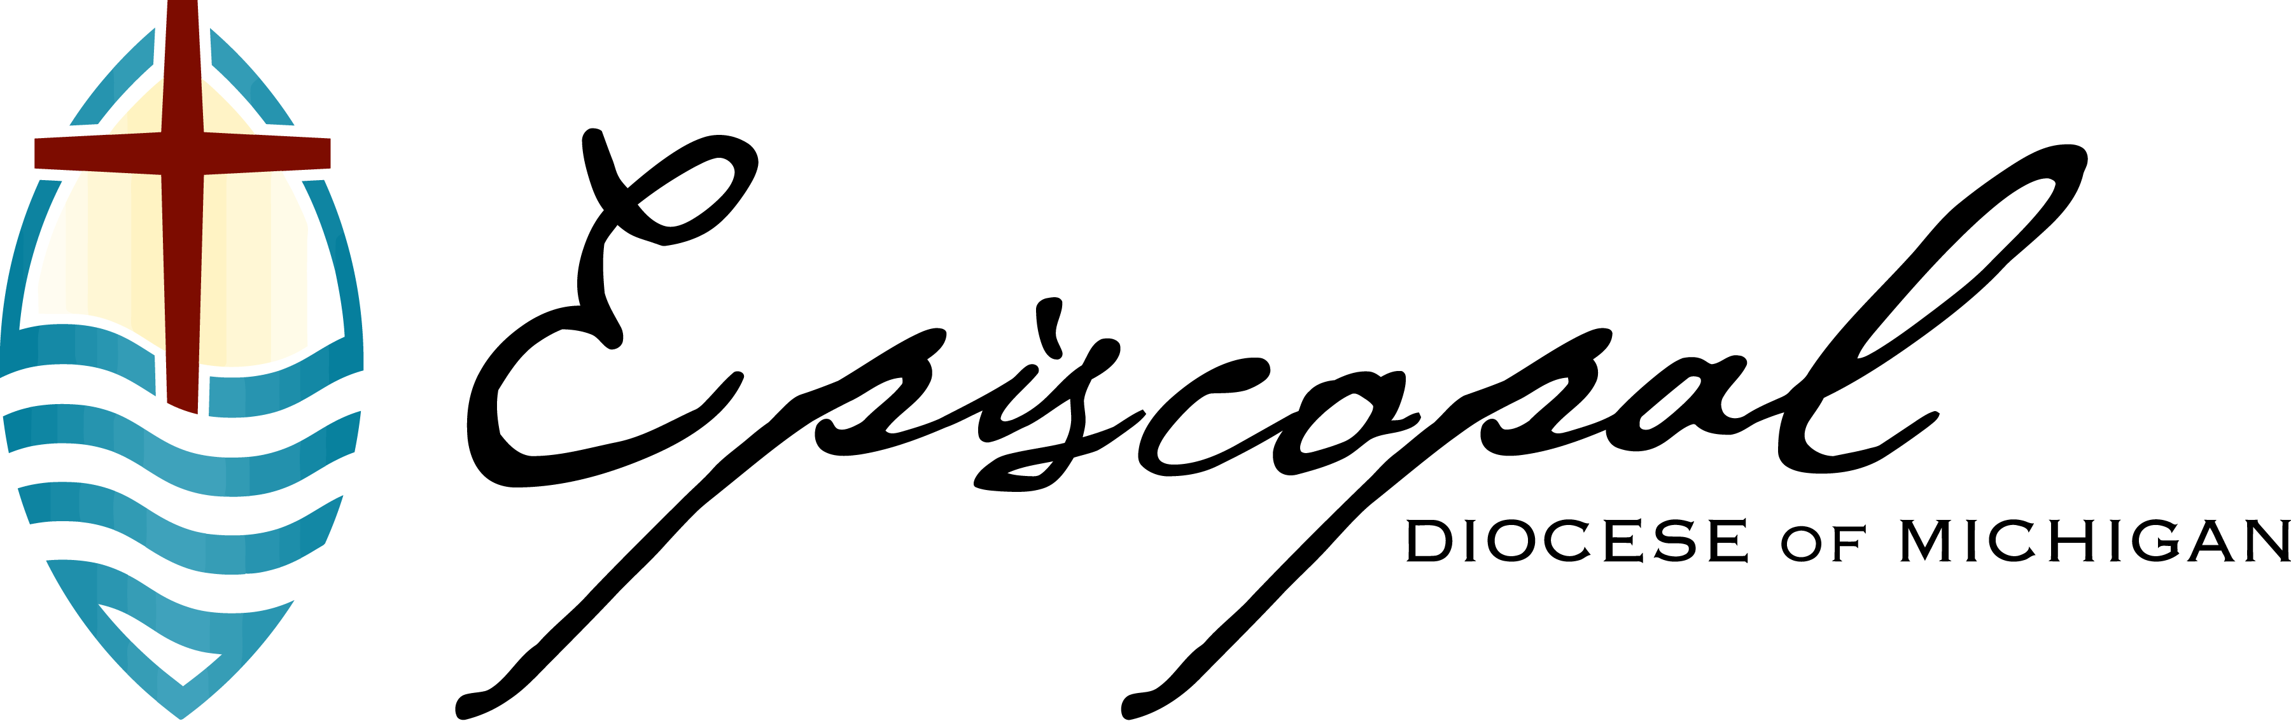

YOUR CHURCH NAME | YOUR CHURCH ADDRESS | YOUR CHURCH CONTACT
#welcomethestranger

